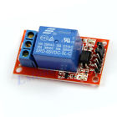**1-Channel H/L Level Triger Optocoupler Relay New Module for Arduino 5V**

* 100% brand new and high quality
* 1-Channel relay module, with photoelectric isolation
* The module can be high or low by a jumper setting trigger
* With power and relay action indicator
* The module Operating voltage 5V
* The module uses genuine quality relay, normally open interfaces Maximum load: AC 250V/10A, DC 30V/10A

Module interface:

* DC+: positive power supply (VCC)(5V)
* DC-: negative power supply (GND)
* IN: The control end, the driving current should be more than 4mA
* COM: The control of loop of earth wire
* 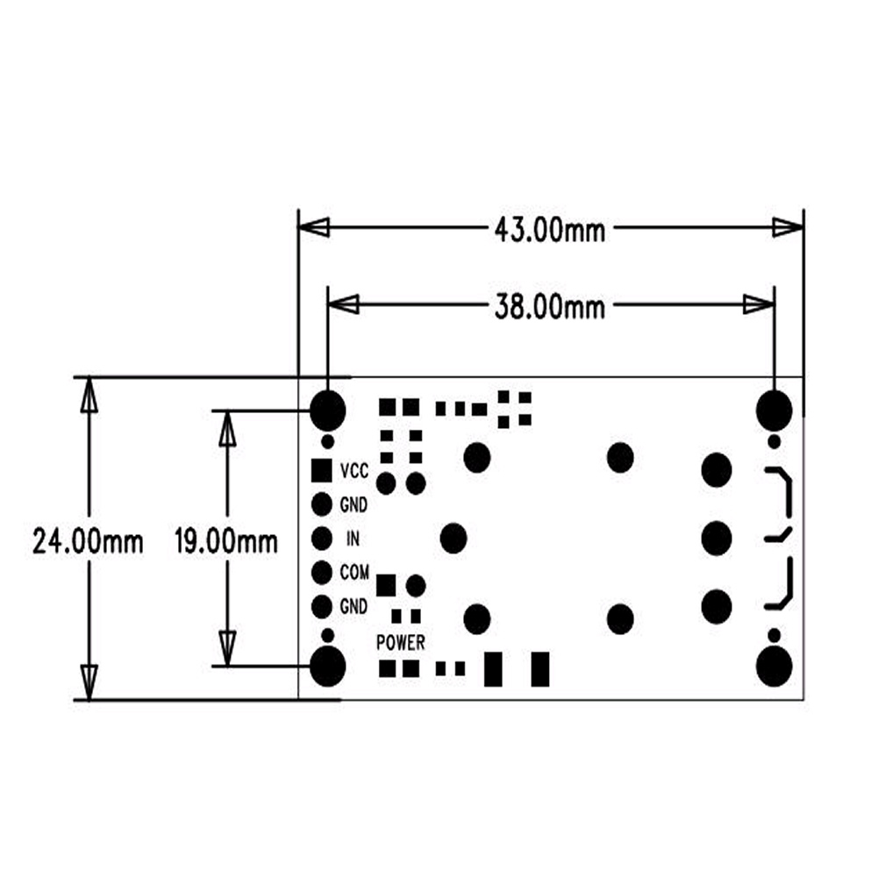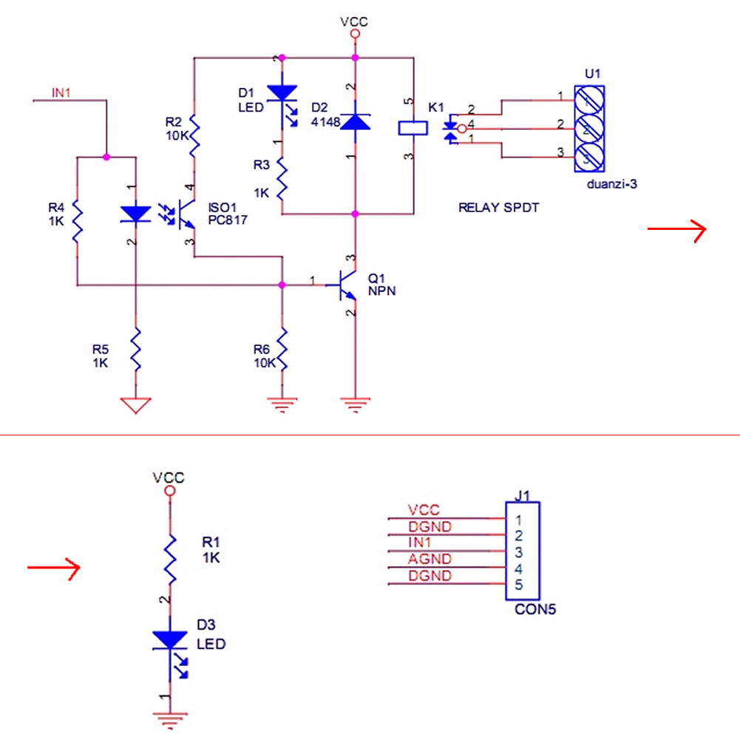

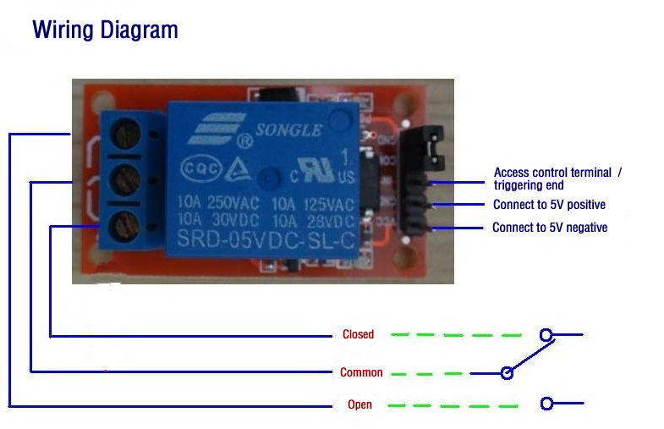

Program :

int RelayPin = 6;

void setup()

{

pinMode(RelayPin,OUTPUT);

}

void loop()

{

char i;

i = analogRead(5);

if(i > 5)

{

digitalWrite(RelayPin,HIGH);

}

else

{

digitalWrite(RelayPin,LOW);

}

}